Documentation WebServer
Contenu
Configuration du Netplan 1
Commandes CLI 2
Configurations des Ports Apache 2
Configuration du VirtualHost (Page Principale) 3
Configuration du VirtualHost (Page Contrôleur) 4
Utilisateurs SQL 4
Connection externe (openssh) 5
Time Zone 5
Migration de la Page Principale 6
Fonctionnalités Optionnels 7

Configuration du Netplan
# This is the network config written by 'subiquity'
network:
ethernets:
enp0s3:
dhcp4: false
addresses:
- 10.1.25.1/16
routes:
- to: default
via: 10.1.0.1
nameservers:
addresses:
- 10.1.0.5
- 10.1.0.10
enp0s8:
dhcp4: false
addresses:
- 10.1.25.2/16
version: 2

Commandes CLI
Installation dans l’ordre
Sudo apt install apach2
Sudo apt install mysql-server
Sudo apt install php
Sudo apt install php-mysql
Sudo apt install phpmyadmin

Activation des pages
Sudo a2dissite 00-default.conf
Sudo a2ensite ecoweighing.conf
Sudo a2ensite controller.conf

Configurations des Ports Apache
# If you just change the port or add more ports here, you will likely also
# have to change the VirtualHost statement in
# /etc/apache2/sites-enabled/000-default.conf

Listen 80
Listen 8080

<IfModule ssl_module>
Listen 443
Listen 8081
</IfModule>

<IfModule mod_gnutls.c>
Listen 443
</IfModule>

Configuration du VirtualHost (Page Principale)
<VirtualHost 10.1.25.1:80>
Redirect permanent / https://10.1.25.1/
</VirtualHost>
<VirtualHost 10.1.25.1:443>
# The ServerName directive sets the request scheme, hostname and port that
# the server uses to identify itself. This is used when creating
# redirection URLs. In the context of virtual hosts, the ServerName
# specifies what hostname must appear in the request's Host: header to
# match this virtual host. For the default virtual host (this file) this
# value is not decisive as it is used as a last resort host regardless.
# However, you must set it for any further virtual host explicitly.
#ServerName www.example.com

ServerAdmin webmaster@localhost
DocumentRoot /var/www/github/PIF-Website/EcoWeighing
DirectoryIndex index.php

# Available loglevels: trace8, ..., trace1, debug, info, notice, warn,
# error, crit, alert, emerg.
# It is also possible to configure the loglevel for particular
# modules, e.g.
#LogLevel info ssl:warn

ErrorLog ${APACHE_LOG_DIR}/ecoweighing/error.log
CustomLog ${APACHE_LOG_DIR}/ecoweighing/access.log combined

SSLEngine on

SSLCertificateFile /etc/ssl/certs/ecoweighing-selfsigned.crt
SSLCertificateKeyFile /etc/ssl/private/ecoweighing-selfsigned.key

# For most configuration files from conf-available/, which are
# enabled or disabled at a global level, it is possible to
# include a line for only one particular virtual host. For example the
# following line enables the CGI configuration for this host only
# after it has been globally disabled with "a2disconf".
#Include conf-available/serve-cgi-bin.conf
</VirtualHost>

Configuration du VirtualHost (Page Contrôleur)
<VirtualHost 10.1.25.2:8080>

ServerAdmin webmaster@localhost
DocumentRoot /var/www/controller
DirectoryIndex index.php

ErrorLog ${APACHE_LOG_DIR}/controller/error.log
CustomLog ${APACHE_LOG_DIR}/controller/access.log combined

</VirtualHost>
<VirtualHost 10.1.25.2:8081>

ServerAdmin webmaster@localhost
DocumentRoot /var/www/controller
DirectoryIndex index.php

ErrorLog ${APACHE_LOG_DIR}/controller/error.log
CustomLog ${APACHE_LOG_DIR}/controller/access.log combined

SSLEngine on

SSLCertificateFile /etc/ssl/certs/controller-selfsigned.crt
SSLCertificateKeyFile /etc/ssl/private/controller-selfsigned.key

</VirtualHost>

Utilisateurs SQL
+------------------+-----------------------+-----------+
| user | plugin | host |
+------------------+-----------------------+-----------+
| admin | caching_sha2_password | localhost |
| debian-sys-maint | caching_sha2_password | localhost |
| ecoweighing | caching_sha2_password | localhost |
| mysql.infoschema | caching_sha2_password | localhost |
| mysql.session | caching_sha2_password | localhost |
| mysql.sys | caching_sha2_password | localhost |
| phpmyadmin | caching_sha2_password | localhost |
| root | auth_socket | localhost |
+------------------+-----------------------+-----------+
8 rows in set (0.00 sec)

Connection externe (openssh)
Via Mobaxterm
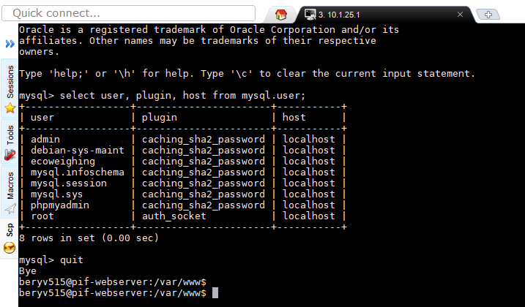

Time Zone
Commande : tzselect
The following information has been given:

Luxembourg

Therefore TZ='Europe/Brussels' will be used.
Selected time is now: Fri Mar 1 13:02:10 CET 2024.
Universal Time is now: Fri Mar 1 12:02:10 UTC 2024.

Migration de la Page Principale
La base de données
mysql> show tables;
+--------------------------+
| Tables_in_db_ecoweighing |
+--------------------------+
| TBLBILL |
| TBLCENTERS |
| TBLMEASURES |
| TBLSCHEDULES |
| TBLSTATIONS |
| TBLSTATIONSTYPE |
| TBLTRASHTYPE |
| TBLUSERS |
+--------------------------+
8 rows in set (0.00 sec)

Le Page Principale (navigateur)
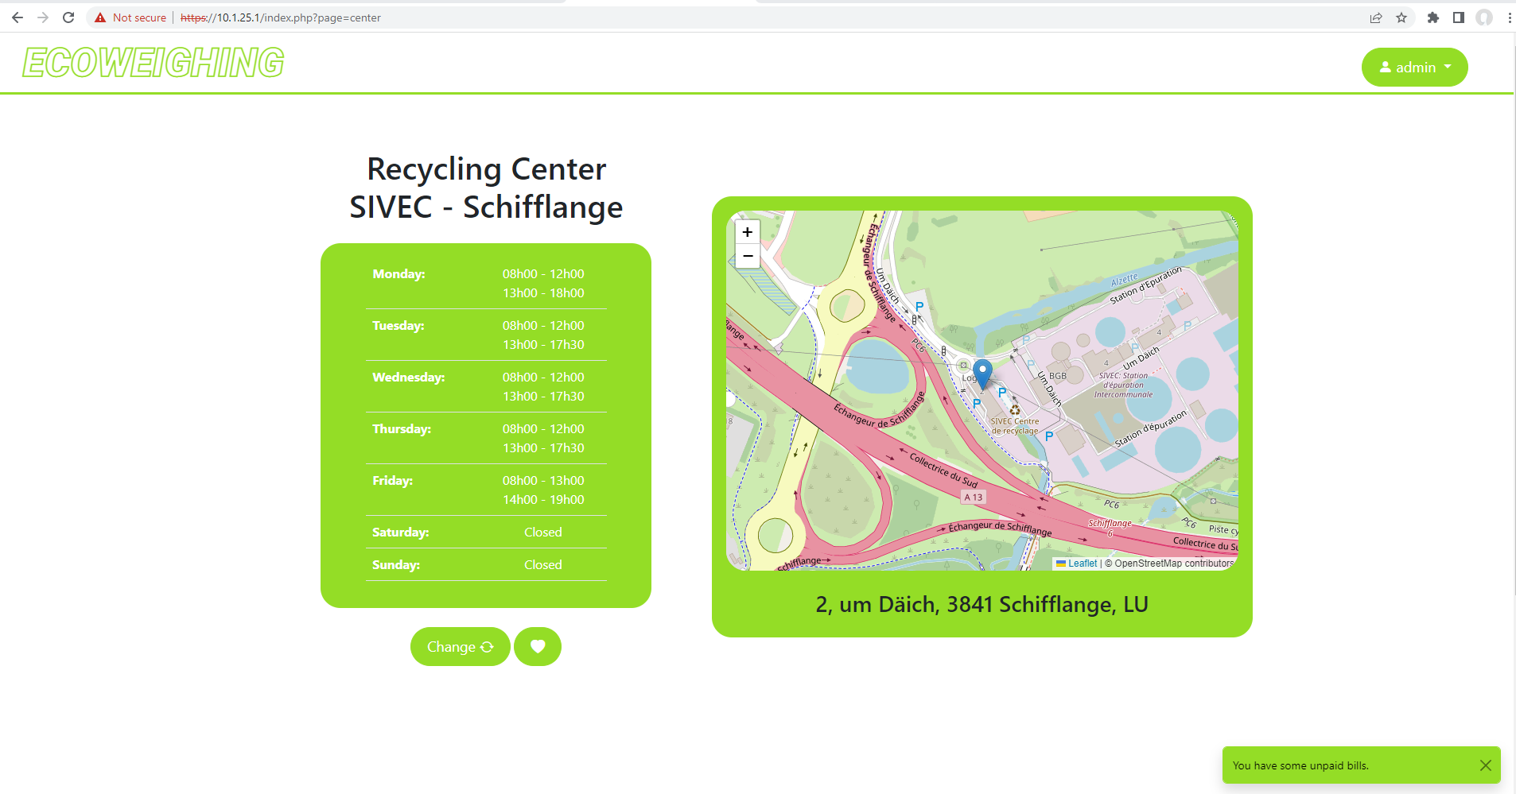

La Page Contrôleur et phpmyadmin
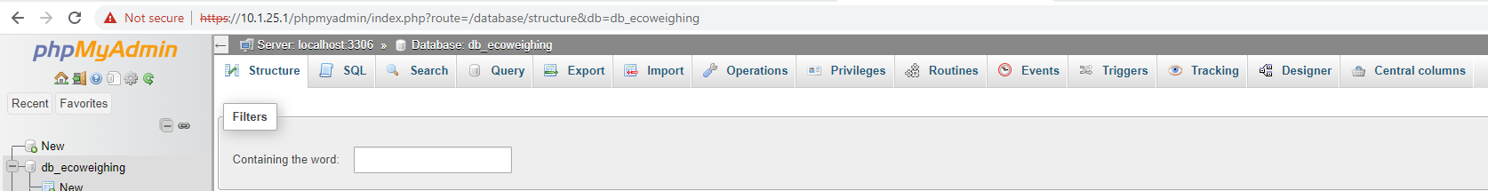

Fonctionnalités Optionnels
- Dernière Version de Apache (ppa:ondrej/apache2)
- Dernière Version de php (ppa:ondrej/php)
- Dernière Version de phpmyadmin (ppa:phpmyadmin/ppa)
- Utilisateur SQL pour le Site Principale (avec permission limité)
- HTTPS et redirection pour la Page principale (port : 443)
- HTTPS pour la Page Contrôleur (port : 8081)
- Ajout de Git et GitHub CLI pour la connexion à mon répertoire GitHub

